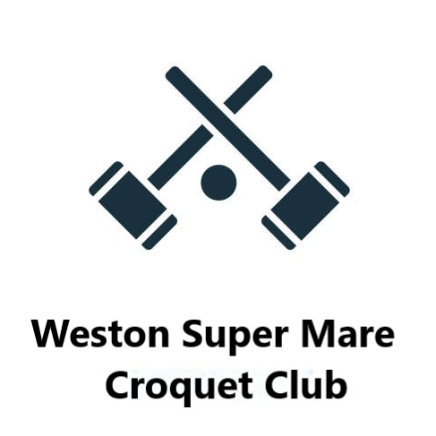

**Newsletter – Winter 2023**

At last the rain has abated for a while! The lake that replaced our lawns was the result of a blocked drain which when cleared by the Landlord swiftly dried up. Graham and James monitored the situation and I am pleased to say that Mike has given the all clear to play on lawn 2. He asks that the boxes are left in the shed and not dragged across the still soggy lawn 3. Also, it is harmful to the grass to play on worm casts – please use the swisher before you play. Mike Dudley has done a great job this year rallying the small group of lawn helpers and who have kept our lawns in good order, of course, as always we need a few more next year to fill the cutting rotas.

Unfortunately the sale of the grounds which is almost agreed has stalled and won’t be completed until the end of 2024. Our sponsors the Nesbit family are still on board and their representative is in touch with Alistair House and will continue the negotiations when his legal problems are sorted out. In the meantime he has done promised work and drastically reduced the hedge on the café side and done some trimming of the border with Bleadon Road. Also at a meeting with Chris (the strimmer) it transpired that he has been allotted time by Alistair to help us during 2024.

We have had the sad news that Rene and Gerry will be moving south in the New Year. They will re-join as Country members next year so we will see them occasionally. Patrice has been appointed secretary of Budleigh Salterton – a huge job and responsibility – we wish her well. We will miss them all.

We have entered one AC team and four GC teams in the SWF leagues and Jan has mustered enough players to enter the annual Short Croquet tournament at Nailsea which is usually held early in the season.

Thank you to all who have contributed to the Bonus ball competition run by Steve. His enthusiasm has resulted in enrolling not only croquet players but whist players and has filled the 59 spaces every week. This has raised £1117 this year - a considerable contribution to Club funds.

The croquet whist drive which moved to Jubilee Hall on Thursday afternoons at 1.30, has not been well supported. However our regular players wish it to continue and it is making a little money for the Club. Maureen, Steve, Pat and Gordon help me each week and we would love to see more Club members join a very convivial afternoon. The last meeting this year will be 21st December and we will resume on January 4th.

Lance has had a procedure on his hand which has been very painful this season so he will be back in action next season. Jan’s op in September is taking some time to heal but she is determined to have her holiday in Morocco so will miss the Christmas lunch. My hip op. two weeks ago was very successful and I am much looking forward to playing next year and maybe reducing my handicap!!

Christmas lunch and prize giving at Beechlands will be our next get together and we will be 36. We will meet at 12.30 for 1.00pm. There is another group sharing the venue so it’s advisable to car share if possible and arrive early.

I wish you all a Happy Christmas and a healthy and peaceful New Year with lots of good croquet.

Kind regards

Pauline